Financial analyst and investor……

Macro economics needs to be understood before you can even start evaluating a company or investment

We will learn how macro affects the real world this knowledge is the real deal then next (very important cos if you get it wrong you are wasting your time)

Next Stocks and shares (stock management )

Investment banking is the core of finance

Portfolio management

Also financial excel data

Then venture capital

Then hedge funds

We learn how to take care of a technology company finance and account we help mr tony shark with virtual reality company

We are currently employed to m.harun company. Now as we ge better shark will try to recruit us to his cfo but we need to say no.



Victor a venture capital analyst may give toney money in exchange for partial ownership of the company(shark), victor does due diligence before deciding to invest in shark virtual reality software. He then invest in sharks company.

Years later he contacts victor his venture capital analyst to say business is boooming .



Victor replies saying



Now he meet Isabelle the investment analyst banker



IPO, initial public offering is a big step for a company

What Is an IPO?

An initial public offering (IPO) refers to the process of offering shares of a [private corporation](https://www.investopedia.com/terms/p/privatecompany.asp) to the public in a new stock issuance. Public share issuance allows a company to raise capital from public investors. The transition from a private to a public company can be an important time for private investors to fully realize gains from their investment as it typically includes share premiums for current private investors. Meanwhile, it also allows public investors to participate in the offering.

A company planning an IPO will typically select an underwriter or underwriters. They will also choose an exchange in which the shares will be issued and subsequently traded publicly.

The term initial public offering (IPO) has been a buzzword on Wall Street and among investors for decades. The Dutch are credited with conducting the [first modern IPO](https://www.investopedia.com/ask/answers/08/first-company-issue-stock-dutch-east-india.asp) by offering shares of the Dutch East India Company to the general public. Since then, IPOs have been used as a way for companies to raise capital from public investors through the issuance of public share ownership. Through the years, IPOs have been known for uptrends and downtrends in [issuance](https://blog.auditanalytics.com/ipo-trends-and-statistics-report/). Individual sectors also experience uptrends and downtrends in issuance due to innovation and various other economic factors. Tech IPOs multiplied at the height of the dot-com boom as startups without revenues rushed to list themselves on the stock market. The 2008 financial crisis resulted in a year with the least number of IPOs. After the recession following the 2008 [financial crisis](https://www.investopedia.com/terms/f/financial-crisis.asp), IPOs ground to a halt, and for some years after, new listings were rare. More recently, much of the IPO buzz has moved to a focus on so-called [unicorns](https://www.investopedia.com/terms/u/unicorn.asp)—startup companies that have reached private valuations of more than $1 billion.

Investors and the media heavily speculate on these companies and their decision to go public via an IPO or stay private.

Volume 75%

**4:46**

**Initial Public Offering (IPO) Explained**

How IPOs Work

Prior to an IPO, a company is considered private. As a private company, the business has grown with a relatively small number of shareholders including early investors like the founders, family, and friends along with professional investors such as [venture capitalists](https://www.investopedia.com/terms/v/venturecapitalist.asp) or [angel investors](https://www.investopedia.com/terms/a/angelinvestor.asp).

When a company reaches a stage in its growth process where it believes it is mature enough for the rigors of SEC regulations along with the benefits and responsibilities to public shareholders, it will begin to advertise its interest in going public. Typically, this stage of growth will occur when a company has reached a private valuation of approximately $1 billion, also known as unicorn status. However, private companies at various valuations with strong fundamentals and proven profitability potential can also qualify for an IPO, depending on the market competition and their ability to meet listing requirements.

An IPO is a big step for a company. It provides the company with access to raising a lot of money. This gives the company a greater ability to grow and expand. The increased transparency and share listing credibility can also be a factor in helping it obtain better terms when seeking borrowed funds as well.

IPO shares of a company are priced through underwriting [due diligence](https://www.investopedia.com/terms/d/duediligence.asp). When a company goes public, the previously owned private share ownership converts to public ownership and the existing private shareholders’ shares become worth the public trading price. Share underwriting can also include special provisions for private to public share ownership. Generally, the transition from private to public is a key time for private investors to cash in and earn the returns they were expecting. Private shareholders may hold onto their shares in the public market or sell a portion or all of them for gains.

Meanwhile, the public market opens up a huge opportunity for millions of investors to buy shares in the company and contribute capital to a company’s shareholders' equity. The public consists of any individual or institutional investor who is interested in investing in the company. Overall, the number of shares the company sells and the price for which shares sell are the generating factors for the company’s new shareholders' equity value. Shareholders' equity still represents shares owned by investors when it is both private and public, but with an IPO the shareholders' equity increases significantly with cash from the primary issuance.



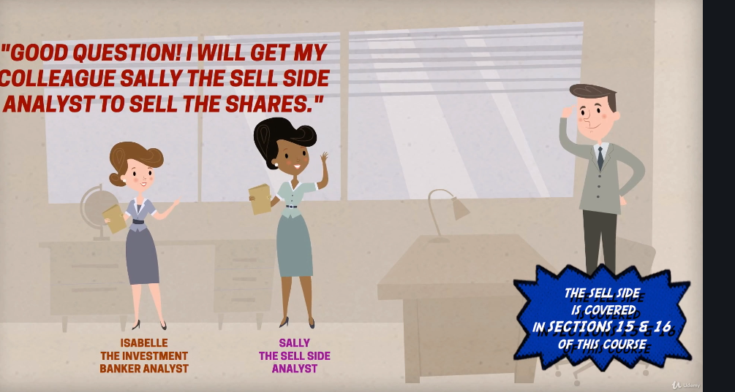



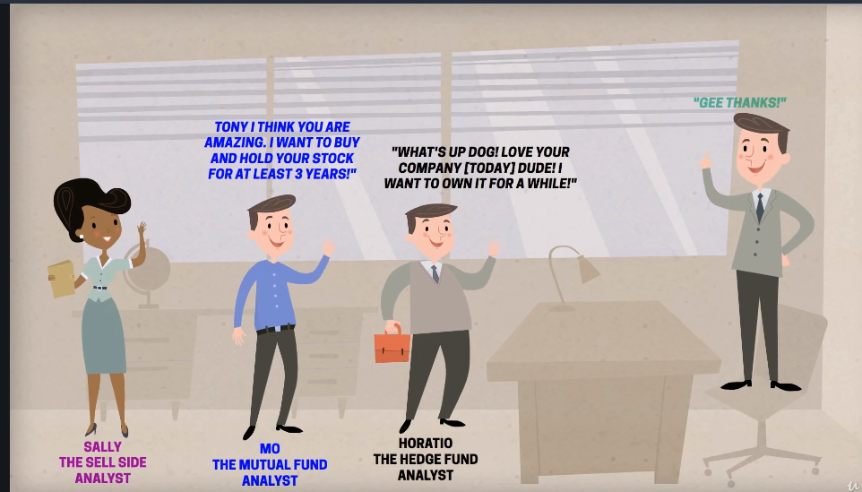



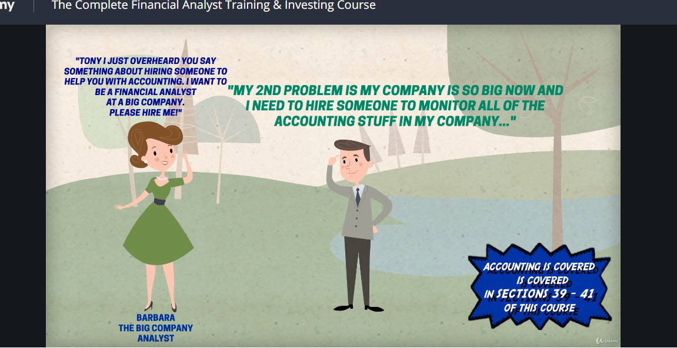









But guess what, there is one more …. Shark…. When a company gets too big and it dies or should be taken out of circulation and restructured, then we have people called sharks and we refer to them as private equity analyst. Who are they we dnt know but will find out as the course goes I believe

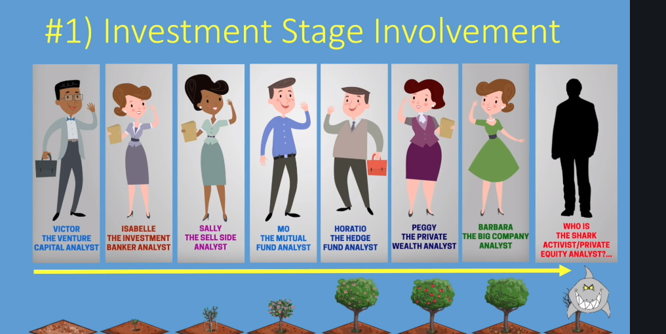

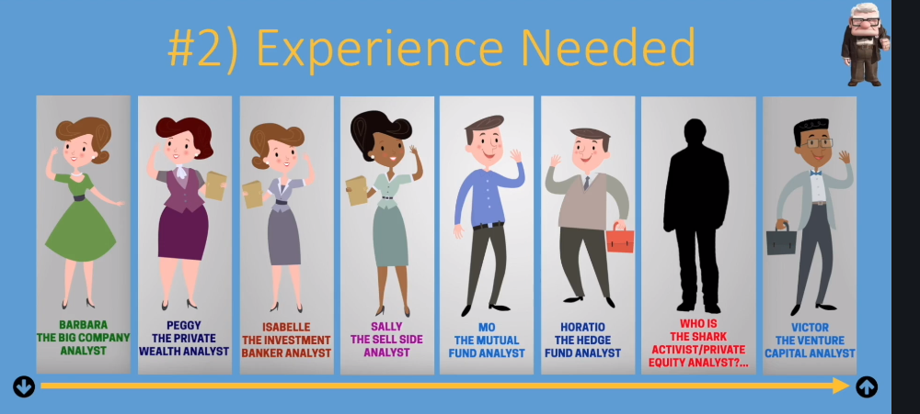

Experience needed gets higher from left to right, gets complicated from, sell side to sharks who tear companies and restructure if needed then the venture capital analyst. Venture capital analyst sit on a lot of board so require a lot of experience especially when giving entrepreneurs advice when sitting on boards.

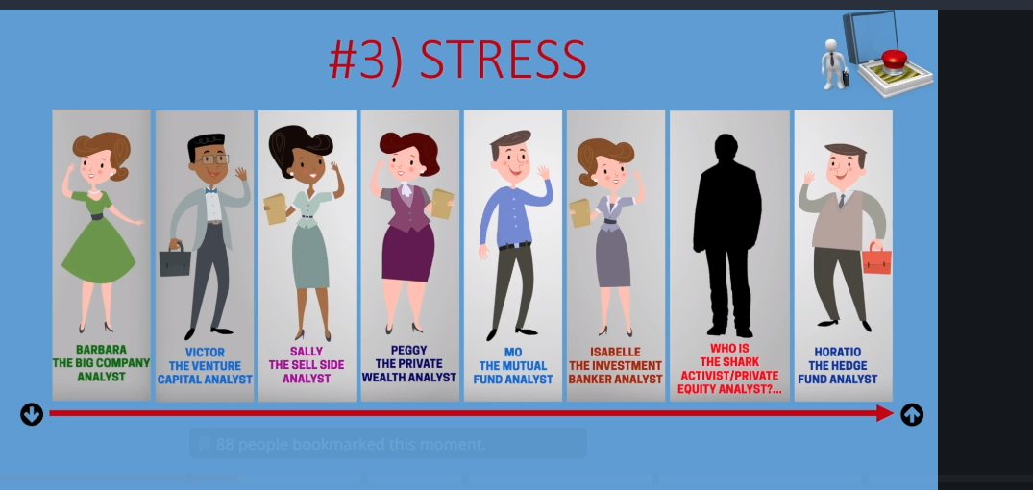

From wealth starts getting stressful. Investment bankers work 100 hrs a week. The hedge fund analyst is the most stressful of all financial services

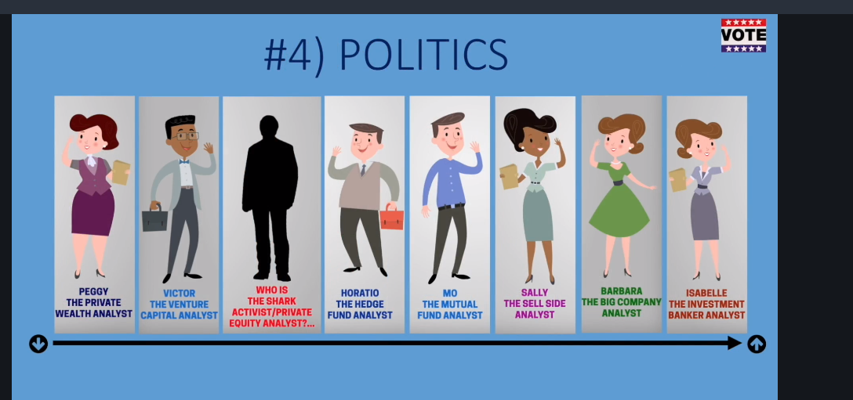

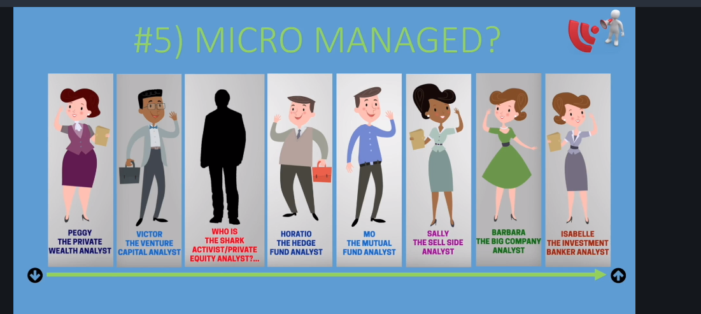

The investment bankers are more micromanaged.

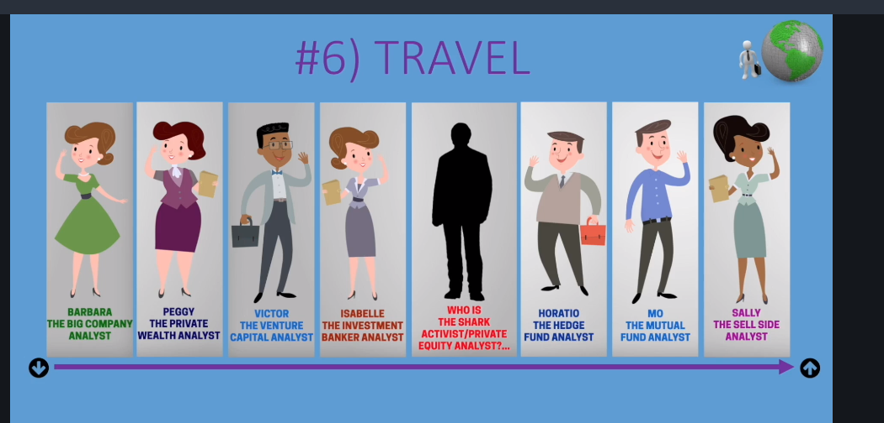



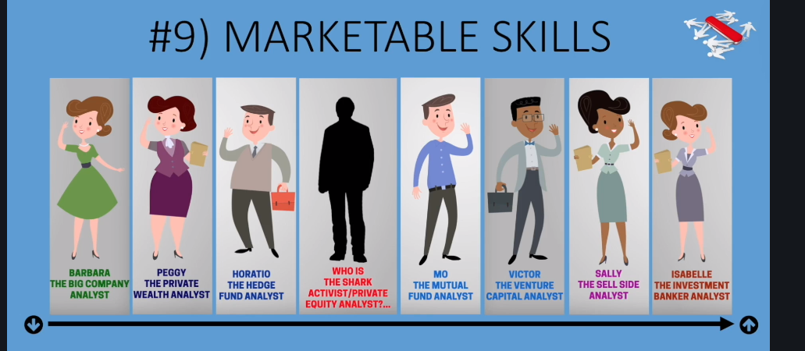

Sell side analyst become company cfo.

14 financial analyst roles to be discussed

Ok test

1. C f a= 4 b= 4 c=2 d= 5 e=2 f=3
2. A b
3. E d
4. A b
5. E f
6. D B
7. D a
8. D c
9. B f
10. D A

If you have a highest

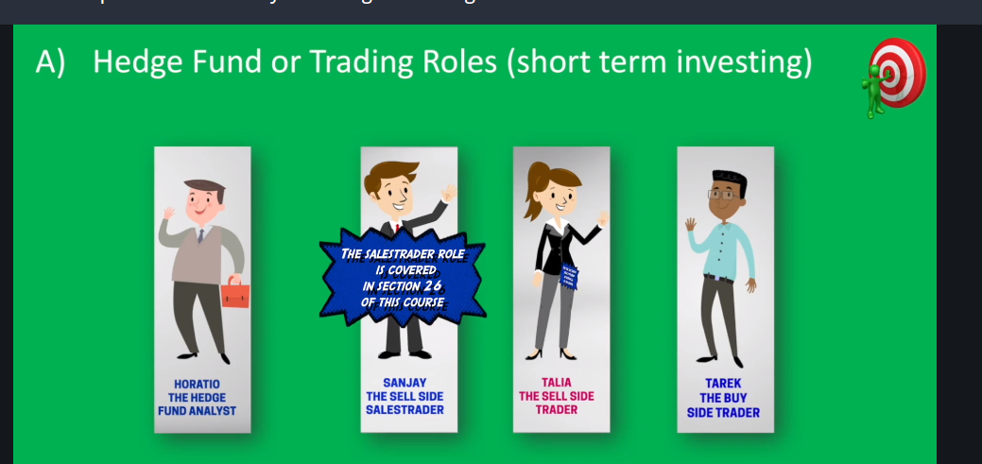

Short term investment

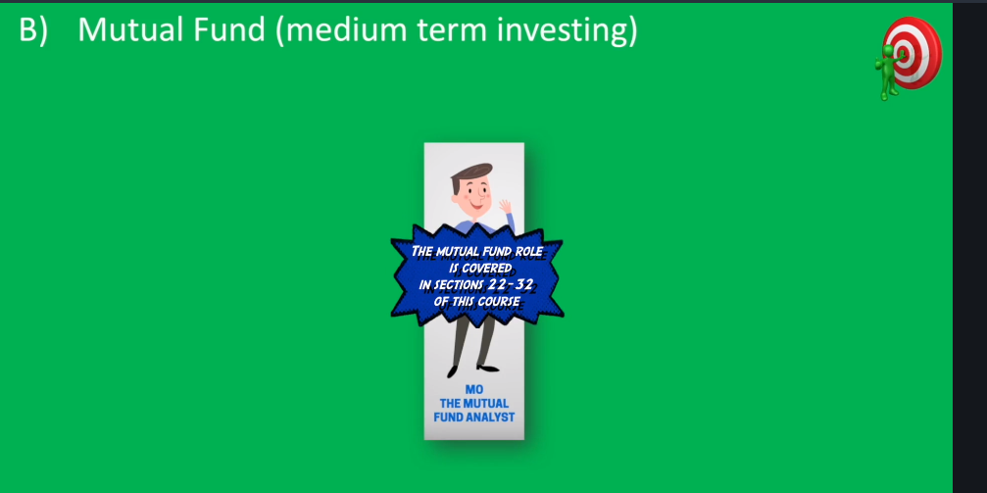

`

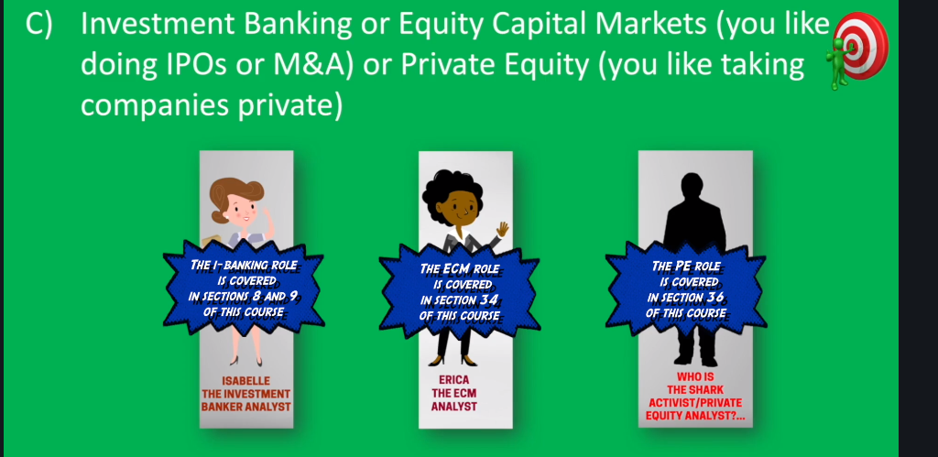

`

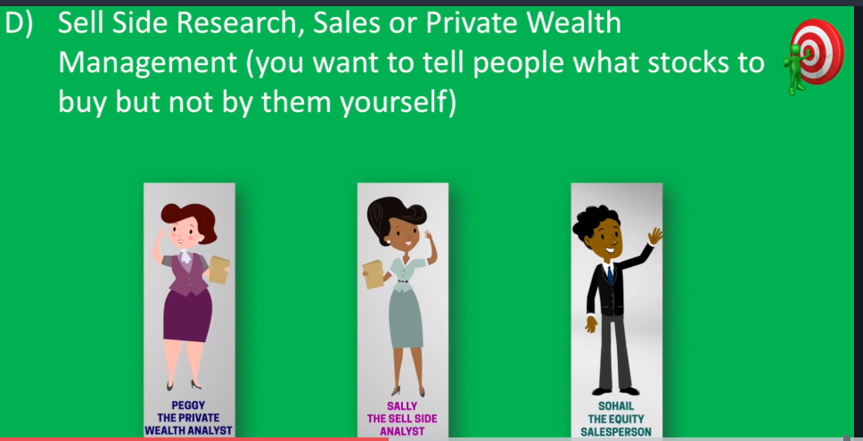

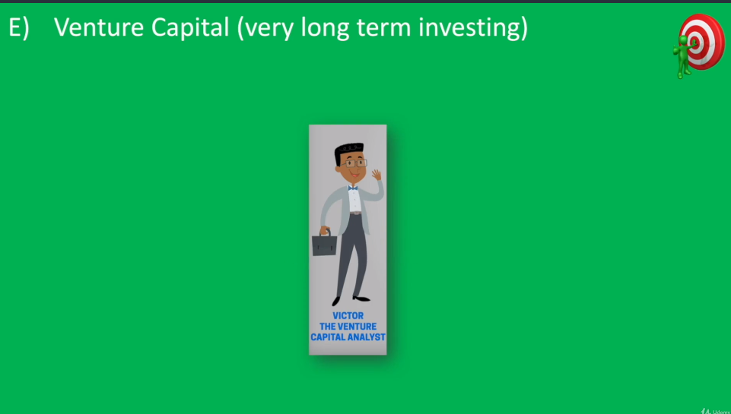

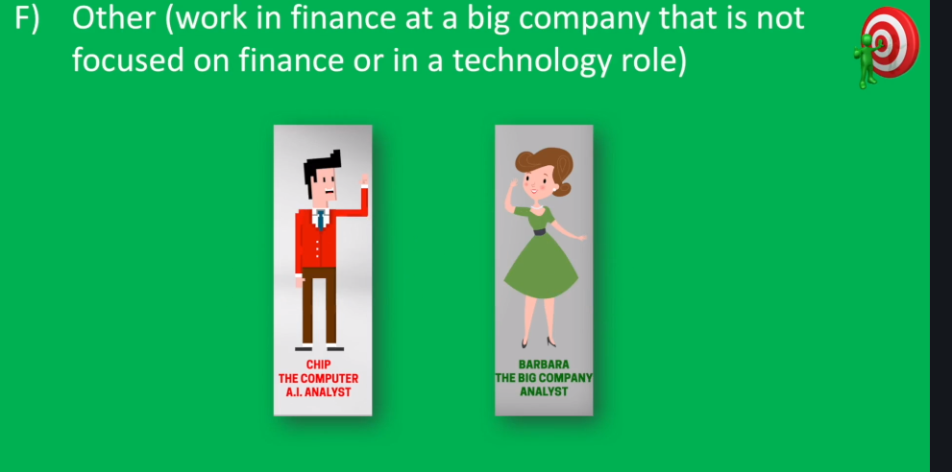

What why how

What three global institutions matters most to a financial analyst

1. IMF
2. World bank WB
3. World Trade Organisation

Why study financial analyst because stocks are dictated by the global market and economy but people only focus on stocks and miss the point

Note if you get the macro wrong, then the micro is meaningless.

Note revenue is called profit for a business but for a country its called gdp gross domestic product… knowledge of macro economy is very critical.

Here we get to understand why currencies decreases and increases and how they change interest rate.

IMF

<http://data.imf.org/?sk=4C514D48-B6BA-49ED-8AB9-52B0C1A0179B>

imf is to make sure global economy is growing facilate internation trade lend money to countres and reduce international world problem.

Imf lent money when spike in oil prices in 1970. When materials are very high it can have an effect on global economy.

Big increase in commodity prices can have negative effects on stock prices

Now trick is to monitor oil price changes because it has a big effect in most companies in the world.

Also construction and cement companies are affected as well and even video games strange irrespective of what industry it is.

If price of gold goes up can be strange.

In the 1990 as communist countries moved towards capitalism

# **Communist Countries 2019**

What is the meaning of communism?

[Communism](https://www.livescience.com/42980-what-is-communism.html) is a political, social, philosophical and economic doctrine aiming to replace private property and a profit-based economy with common ownership of major means of production. Communism aims to diminish the two classes of society – the working class and the capitalist class – so that the capitalist class will no longer profit off of the working class.

+-

Communism goes against many western principles; therefore, communism is rejected by most western countries. Communism’s state-controlled economy and totalitarian government are greatly opposed by the capitalist, democratic nations in [Europe](http://worldpopulationreview.com/continents/europe-population/), the Americas, and all over the world.

What are the major differences between capitalism and communism? What are the characteristics of communist countries? Are there currently any communist countries in the world?

### Capitalism vs. Communism

Capitalism is an economic system involving free trade and industry that is own and controlled by individuals to make a profit. Wealth distribution depends on the individual, as every person needs to work for themselves in order to generate wealth, which allows for class distinction and for the profit of enterprises to b enjoyed by the owner(s).

Unlike capitalism, communism does not allow private ownership of trade or industry and everything has common ownership. Wealth is distributed as per needs and ability and allows for an egalitarian system (all people are equal and deserve equal rights and opportunities). All profits earned by the enterprise are distributed among all the people, unlike capitalism where it is enjoyed by the owner only.

While capitalism has a democratic system of government with little government interference, communism has a totalitarian government with high government involvement. This is one of the main reasons why western countries see communism as a threat.

## The Foundation of Communism

A Communist country is a nation that is governed by a single party, and the foundation of the ruling leaders’ decisions is based on the philosophies of [Marx and Lenin](https://www.marxists.org/history/erol/ncm-7/lrs-baraka-2.htm). To fully understand the basis of communism, it helps to learn more about Marx and Lenin, both of whom were philosphers of the nineteenth and twentieth centuries.

### Karl Marx

Karl Marx was born on May 5, 1818. Born in [Germany](http://worldpopulationreview.com/countries/germany-population/), Marx grew up to become a philosopher who based his beliefs on aspects of economics, history, journalism, political theory, revolutions, and sociology. He established a way of thinking known as Marxism.

Essentially at its core, Marxism advocates for the working class of an economy. It zeroes in on the differences between classes and how that impacts the functioning of a society. The theory views capitalism as the source of many problems, and Marxism is in direct conflict with capitalistic societies. Marxism views capitalism as the cause of lower wages, heightened selfish behaviors, and greed surrounding wealth, as well as the ever-present emphasis on productivity in capitalistic societies.

Through the lens of Marxism, the political agenda that Communism promotes is seen as a form of socialism. The two phases of Communism, as identified by Marx, explain how Communism unfolds and then becomes regularly practiced in a country.

The two phases identified by Marx are...

1. Capitalism
2. Socialism

Marx conveyed an idea that countries have to understand capitalism before they can move onto the elevated state that socialism provides. It has been said by Karl Marx that nations will not understand how to uphold a country politically affiliated with Communism if they do not first master the art of capitalism. This applies primarily to third-world countries that need to start from the ground up, not countries that already have a stable grip on their economy.

The end goal of the two-step process is a country that operates under Communist ideologies. In theory, it would be wonderful for nations to be able to make the jump from underdeveloped with no government, to successful and functional without a government, but that is not how it would unfold in the real world.

The reality of that situation would be a chaotic nation that experiences turmoil and corruption. For example, people would need to be paid based on the quality and quantity of their work. But if this understanding is not already deeply ingrained in a society, then everyone would act selfishly and seek success for themselves at the literal expense of everyone else.

The basics need to be instilled, first and foremost. From there, the country will be able to enter the second phase. At this point, the nation would be viewed as a country that implements fully-realized communism, where class divisions and government are no longer in existence.

### [Vladimir](http://worldpopulationreview.com/world-cities/vladimir-population/) Lenin

Born on April 22, 1870, Vladimir Lenin followed in the footsteps of Marx in that Lenin was a philospher who analyzed politics and crafted theories around what he saw. Lenin did not have identical beliefs to Karl Marx, but his ideologies were deeply rooted in Communism, much like Marx.

Leninism goes so far as to proclaim that socialism can only be achieved once the working class reaches a level of political consciousness that government officials withhold. The working class, under Leninism beliefs, can only overthrow the government and successfully instill socialism once the people understand how the government works. The basic idea is to get inside the heads of government officials, figure out how they operate, and then find ways to unravel their power.

### When Marxism and Leninism Combine

Under the combined political theory of Marxism and Leninism, the concept of private property and an economy centered on profits are replaced with public ownership. An overall communal control of both natural resources and the means of production are also characteristics of communism. This includes open access to mills, factories, and mines to name a few sources of production. During the twentieth century, about one-third of the world’s population lived under Communist rule. The region that contained the most heavily concentrated Communist countries was the Soviet Union.

The Soviet Union experienced an inefficient economy, and the poor performance of the Soviet Union led to the country’s economc collapse in the early 1990s.

The countries that were formerly part of the Soviet Union include...

* [Armenia](http://worldpopulationreview.com/world-cities/armenia-population/)
* [Azerbaijan](http://worldpopulationreview.com/countries/azerbaijan-population/)
* [Belarus](http://worldpopulationreview.com/countries/belarus-population/)
* [Estonia](http://worldpopulationreview.com/countries/estonia-population/)
* [Georgia](http://worldpopulationreview.com/states/georgia-population/)
* [Kazakhstan](http://worldpopulationreview.com/countries/kazakhstan-population/)
* [Kyrgyzstan](http://worldpopulationreview.com/countries/kyrgyzstan-population/)
* [Latvia](http://worldpopulationreview.com/countries/latvia-population/)
* [Lithuania](http://worldpopulationreview.com/countries/lithuania-population/)
* [Moldova](http://worldpopulationreview.com/countries/moldova-population/)
* [Russia](http://worldpopulationreview.com/countries/russia-population/)
* [Tajikistan](http://worldpopulationreview.com/countries/tajikistan-population/)
* [Turkmenistan](http://worldpopulationreview.com/countries/turkmenistan-population/)
* [Ukraine](http://worldpopulationreview.com/countries/ukraine-population/)
* [Uzbekistan](http://worldpopulationreview.com/countries/uzbekistan-population/)

As [World](http://worldpopulationreview.com/continents/world-population/) War II started coming to an end, many European countries were divided based on the political parties they supported. Nations took sides, with some countries supporting the Axis Powers, while others were in full support of the Allies. A handful of countries that were in agreeance with the Allies became known as the Soviet-controlled Eastern Bloc.

The countries that made up the [Eastern Bloc](https://www.worldatlas.com/articles/what-was-the-eastern-bloc.html) were in favor of communism, and they were officially controlled by the Soviet Union.

These countries included...

* [Bulgaria](http://worldpopulationreview.com/countries/bulgaria-population/)
* The [Czech Republic](http://worldpopulationreview.com/countries/czech-republic-population/)
* East Germany
* [Hungary](http://worldpopulationreview.com/countries/hungary-population/)
* [Poland](http://worldpopulationreview.com/countries/poland-population/)
* [Romania](http://worldpopulationreview.com/countries/romania-population/)
* [Slovakia](http://worldpopulationreview.com/countries/slovakia-population/)

The group of countries known as the Balkans were also under total Communist rule. These Balkan countries were recognized as...

* [Albania](http://worldpopulationreview.com/countries/albania-population/)
* Bosnia and Herzegovina
* Bulgaria
* [Croatia](http://worldpopulationreview.com/countries/croatia-population/)
* The Republic of [Macedonia](http://worldpopulationreview.com/countries/macedonia-population/)
* [Montenegro](http://worldpopulationreview.com/countries/montenegro-population/)
* [Serbia](http://worldpopulationreview.com/countries/serbia-population/)
* [Slovenia](http://worldpopulationreview.com/countries/slovenia-population/)

Various Asian, Middle Eastern, and African countries that once were communist include…

* [Afghanistan](http://worldpopulationreview.com/countries/afghanistan-population/)
* [Angola](http://worldpopulationreview.com/countries/angola-population/)
* [Benin](http://worldpopulationreview.com/countries/benin-population/)
* [Cambodia](http://worldpopulationreview.com/countries/cambodia-population/)
* The Democratic Republic of Congo
* [Eritrea](http://worldpopulationreview.com/countries/eritrea-population/)
* [Ethiopia](http://worldpopulationreview.com/countries/ethiopia-population/)
* [Mongolia](http://worldpopulationreview.com/countries/mongolia-population/)
* [Mozambique](http://worldpopulationreview.com/countries/mozambique-population/)
* [Somalia](http://worldpopulationreview.com/countries/somalia-population/)
* [Yemen](http://worldpopulationreview.com/countries/yemen-population/)

## Communism Today

While there are many countries that were previously under Communist rule, what countries are still Communist today?

Is Russia a Communist country? Communism in Russia ended after the dissolution of the Soviet Union. Russia’s 1993 constitution declares Russia a democratic, federative, law-based state with a republican government. Russia has a dual executive consisting of a president and prime minister with the president, currently Vladimir Putin, as the dominant figure.

[China](http://worldpopulationreview.com/countries/china-population/) is one of the four remaining Communist countries. The Communist Party of China is the founding and sole governing political party of the People’s Republic of China.

[Vietnam](http://worldpopulationreview.com/countries/vietnam-population/), also known as the Socialist Republic of Vietnam, is also one of the four remaining Communist countries. In Vietnam’s third constitution, written in 1980, the Communist Party was stated as the only party to represent the people and lead the country.

[Cuba](http://worldpopulationreview.com/countries/cuba-population/) is currently a Communist country. Cuba is ruled by the Communist Party of Cuba, whose role is described in the Cuban constitution as the “leading force of society of the state.” The Communist Party of Cuba adheres more strictly to the tradition of Marxism-Leninism and the Soviet model than the Communist parties of other countries.

[Laos](http://worldpopulationreview.com/countries/laos-population/), or the Lao People’s Democratic Republic, is one of the remaining Communist countries. The country’s only political party is the Lao People’s Revolutionary Party, whose general secretary, Bounnhang Vorachith, is also the president.

Cambodia was a Communist state under the rule of Khmer Rouge, which took over in 1970. Cambodia became a constitutional monarchy in 1993 with a king as head of state, a prime minister as head of government, and a parliamentary form of government.

[North Korea](http://worldpopulationreview.com/countries/north-korea-population/) is considered to be a Communist country; however, it does not consider itself to be one. North Korea is a “dictatorship of people’s democracy.” After the collapse of the Soviet Union, North Korea revised its constitution to remove all references to Marxism-Leninism. All references to Communism were removed from the North Korean Constitution in 2009.

There are only five remaining Communist countries in the world as of [2019](https://www.worldatlas.com/articles/list-of-communist-countries-today.html). The modern-day Communist countries are…

* China
* Cuba
* Laos
* North Korea
* Vietnam

Remember to register alerts from the imf using that link above.

GDP shows how much a company makes not including expenses.if a country makes more money than it spends then it has a supplus and if vise versa it’s a deficit.

[www.imf.org](http://www.imf.org)

full of information

When the economy in stock market is doing well we call it a bull market and when it is not doing well we call it a bear market.

Imf is predicting that the world gross gdp will be 98 trillion dollars by 2020

Us consumers comprise 2/3 of the economy not the companies, it the consumers spending which is the engine of growth in America.

Visualising data with imf

How a sector moves affects how a stock moves.

To analyse data look at the source and the source of the source to analyse data